**3、Model 1：Water Demand Forecast**

**3.1 Introduction**

In order to devise an effective water strategy ,we firstly need to predict the water demand of 2025 in different provinces ,which should be satisfied in 2025.But,as for the water resource of different regions ,we believe that the total amount of water resource will just change little .Thus we choose the average total water resources as the water supply of 2025. The determination of the water demand and water supply is the first step of our work.

**3.2 Assumption**

1.Assume that the population of China don’t have dramatic change from 2013 to 2025.

2. Assume that the world’s climate don’t have dramatic changes from 2013 to 2025

3.Assume that the water resources don’t have sharp change in 2013-2025.

4. Assume that the water consumption is subdivided into 4 aspects ,agriculture water consumption ,industrial water consumption ,domestic water consumption and ecological water consumption .

**3.3 Data Collection**

From Chinese National Data,We find the date of agriculture water consumption ,industrial water consumption ,domestic water consumption and ecological water consumption in 31 provinces of China (expect HongKong ,Macao ,and Taiwan).

**3.4 Data Preprocessing**

In order to smoothen the data fluctuation ,moving average method is applied to processing data we have collected .

To quantify the processed data ,we use symbol .

(3.4.1)

Where , is set to measure the actual water demand in 2004-2013.，the symbol i means the year.

**3.5 Grey Forecasting Model**

The Grey Forecasting don’t need a bag scale of data. ,and the accuracy of prediction is good .what’s more ,the sample do not need to have regular distribution .And the most important one is that Grey Forecasting is suitable for mid-long term prediction .So ,we decide to use Grey Forecasting Model to predict the water demand of 2025.

**3.5.1 Model Establishing**

**Step 1**:We use raw date sequence ,and calculate first-order accumulated generating operation sequences ,which can fix the ordinary differential equation  (3.5.1.1)

in which both  and are constant .

In the ordinary differential equation ,initial conditions is that when , ,

its solution is

 , (3.5.1.2)

and the discrete value of systematic sampling is

 (3.5.1.3)

**Step2**: Turn the initial data series into the scheme as followed ,and build matrix B and matrix y .







**Step 3**:finding inverse matrix 

**Step 4**:according to ,find the estimated value  and .

**Step5**:put the  and  we have found into (3.5.1.2) ,find the time corresponding equation.

 (3.5.1.4)

Then according to this time corresponding equation ,fit ,and through post reduction operation restore.

**Step6**: Precision examination and forecast

**3.5.2 model solution**

Solve the model by MATLAB programming (the procedure can be seen in the appendix 1)

**3.5.3 precision and error analysis**

In order to measure precision of prediction , the symbol is set to measure posterio tidal specific value ,and we find ,the grade of precision of prediction is good.

**3.5.4 make prediction**

We use GM to predict the water demand of 31provinces of China in 2025,the result is showed in the Table 1.

Table 1

The water demand of 31 provinces in 2025

|  |  |  |  |
| --- | --- | --- | --- |
| province | Water demand(a hundred million ) | province | Water demand (a hundred million ) |
| Beijing | 35.58548 | Hubei | 192.8349 |
| Tianjin | 14.32885 | Hunan | 170.8843 |
| Hebei | 95.22277 | Guangdong | 219.9288 |
| Shanxi | 79.18879 | Guangxi | 152.5635 |
| Inner Mongolia | 130.0331 | Hainan | 21.75406 |
| Liaoning | 84.11661 | Chongqing | 55.22924 |
| Jilin | 108.5643 | Sichuan | 154.3189 |
| Heilongjiang | 324.4045 | Guizhou | 47.63984 |
| Shanghai | 61.44183 | Yunnan | 79.76171 |
| Jiangsu | 322.3394 | Tibet | 15.83909 |
| Zhejiang | 98.86673 | Shanxi | 56.66433 |
| Anhui | 236.049 | Gansu | 60.87873 |
| Fujian | 127.6681 | Qinghai | 14.21477 |
| Jiangxi | 178.3666 | Ningxia | 35.48194 |
| Shandong | 121.1379 | Xinjiang | 369.8732 |
| Henan | 141.6681 |  |  |

**4、Model 2：Water Transfer**

**4.1 Introduction**

According to the result of Model 1 ,we can know the water demand in 2025,compared with the total amount of the water demand in different provinces ,we will find that some provinces will suffer from the lack of water ,so the movement of water resources is crucial to the development and people’s living .

Single goal programming can solve the problem about optimization .The goal of our model is to determine the water transfer route with the lowest cost .So we set up a single goal programming model to solve the problem about water transfer .

**4.2 Assumption**

1.Assumse that the cost of transferring is fixed ,and the cost of transportation between two different regions is same .

2.In order to simply the model ,we define the distance between two provinces as the distance between the capitals of the two provinces .

**4.3 Data Collection**

In this part ,we not only need the data about water demand ,but also need the data about water supply ,that is ,the total amount of water resources of 31 provinces .

**4.4 Data Preprocessing**

We set up a distance matrix D .

$D_{ij}$ means the distance between the $i^{th}$ province and the $j^{th}$ province .

**4.5 Model Establishing**

The symbol f is set to indicate the total cost of water transfer .so ,the objective function of our model is :



s.t.

where *i* means the $i^{th}$ province , *j* means the $j^{th}$ province , $x_{ij}$ means the amount of water which is transferred from the $i^{th}$ province to the $j^{th}$ province . $U_{I}$ means industrial water consumption .

√Matrix *A* is set up to record the water transferring scheme ,when the water is transferred from the $i^{th}$ province into the $j^{th}$ province , $A_{ij}$ =1;when the water is transferred from the $j^{th}$ province into the $i^{th}$ province , $A_{ij}$ =-1; when the provinces don’t need to transfer and be transferred , $A_{ij}$ =0.

Through MATLAB programming ,we can get the matrix *A* .

√ $c_{ij}$ can are defined as the formula below .

$c_{ij}=\left\{\begin{aligned}w i=j \\ D_{ij}×cs i≠j \end{aligned}\right.$ (4.5.2)

Where *cs* means the cost of transferring water from a province to another province . *w* means the cost of wastewater treatment ,and W can be calculated by the formula below:

W= $u*$ w (4.5.3)

in which u means the amount of water to be handled ,w means the cost of handling 10 million ton water .

√*b* can be calculated by the formula below:

${ b}_{i}=d_{i}-0.8*s_{i}$ (4.5.4)

where $d_{i}$ means the demand of the water of the $i^{th}$ province , $s_{i}$ means the water resources of the $i^{th}$ province .The reason for setting the value 0.8 is to guarantee that provinces transferring water to others will store more water for themselves ,and the provinces transferred will obtain more water for themselves .

**4.6 Model solving**

**4.6.1 The initial result**

We find that the cost of sewage treatment is 1.56 RMB per ton ,and the cost of transferring water from a province to another province is 0.3019 per ton .

Namely ,

$$cs= 0.3019*{10}^{8}$$

$$w=1.56*{10}^{8}$$

Solve the model by MATLAB programming ,we can know the provinces which need to transfer water or to be transferred ,or the amount of sewage needed to be handled .The initial result is showed in the table 3 .

Table 3

The initial result(1) transfer

|  |  |  |  |  |
| --- | --- | --- | --- | --- |
| Transferring | Transferred | Amount(10 million ton) | Character | Unit cost  (per ton) |
| Liaoning | Beijing | 18.6213 | Water transfer |  |
| Liaoning | Tianjin | 5.285784 | Water transfer | 96.48197 |
| Zhejiang | Shanghai | 26.56444 | Water transfer | 32.39346 |
| Anhui | Jiangsu | 100 | Water transfer | 37.02555 |
| Hubei | Shanghai | 7.041116 | Water transfer | 90.10438 |
| Shaanxi(陕西) | Hebei | 4.370834 | Water transfer | 126.2754 |
| Shaanxi（陕西） | Shanxi | 8.230427 | Water transfer | 127.356 |
| Qinghai | Ningxia | 26.45566 | Water transfer | 81.34174 |

Table 4

The initial result(2) Sewage treatment

|  |  |  |  |  |
| --- | --- | --- | --- | --- |
| Transferring | Transferred | Amount(10 million ton) | Character | Unit cost  (per ton) |
| Tianjin | Tianjin | 1.6831 | Sewage treatment | 1.56 |
| Hebei | Hebei | 5.9239 | Sewage treatment | 1.56 |
| Shanxi | Shanxi | 3.65436 | Sewage treatment | 1.56 |
| Shanghai | Shanghai | 18.3014 | Sewage treatment | 1.56 |
| Jiangsu | Jiangsu | 52.08231 | Sewage treatment | 1.56 |
| Shandong | Shandong | 2.385942 | Sewage treatment | 1.56 |
| Ningxia | Ningxia | 2.290274 | Sewage treatment | 1.56 |

**4.6.2 The final result**

Now we take sea water desalination in account .Select the coastal cities from the cities which needed to transfer and be transferred .Those cities are :Tianjin ,Hebei ,Shanghai ,and Jiangsu .

Though internet ,we find out the cost of sea water desalination is 4 RMB per ton.

Then we make a comparison ,the result can be seen in the table 4

Table 5

Comparison between transfer and sea water desalination

|  |  |  |  |
| --- | --- | --- | --- |
| Province | The amount of water (10 million ton) | The cost of transfer(10 million yuan) | The cost of c(10 million yuan) |
| Tianjin | 5.285784 | 96.48197 | 21.14314 |
| Hebei | 4.370834 | 126.2754 | 17.48334 |
| Shanghai | 26.56444 | 32.39346 | 106.2578 |
| Jiangsu | 7.041116 | 37.02555 | 28.16446 |

In this 4 provinces ,sea water desalination is more economical .

Therefore ,the final result is shown in the table 5 .

Table 6

The final result

|  |  |  |  |  |
| --- | --- | --- | --- | --- |
| Transferring | Transferred | Amount(10 million ton) | Character | Unit cost  (per ton) |
| Tianjin | Tianjin | 1.6831 | Sewage treatment | 1.56 |
| Hebei | Hebei | 5.9239 | Sewage treatment | 1.56 |
| Shanxi | Shanxi | 3.65436 | Sewage treatment | 1.56 |
| Liaoning | Beijing | 18.6213 | Water transfer | 18.6213 |
| Liaoning | Tianjin | 5.285784 | Water transfer | 4 |
| Shanghai | Shanghai | 18.3014 | Sewage treatment | 1.56 |
| Jiangsu | Jiangsu | 52.08231 | Sewage treatment | 1.56 |
| Zhejiang | Shanghai | 26.56444 | Water transfer | 4 |
| Anhui | Jiangsu | 100 | Water transfer | 4 |
| Shandong | Shandong | 2.385942 | 1.56 | 1.56 |
| Hubei | Shanghai | 7.041116 | Water transfer | 90.10438 |
| Shaanxi(陕西) | Hebei | 4.370834 | Water transfer | 4 |
| Shaanxi（陕西） | Shanxi | 8.230427 | Water transfer | 127.356 |
| Qinghai | Ningxia | 26.45566 | Water transfer | 81.34174 |
| Ningxia | Ningxia | 2.290274 | Sewage treatment | 1.56 |

**5.Model 3: Water Storage**

**5.1 Introduction**

In China ,the time distribution is uneven .In order to solve this problem ,we need to storage water when rivers floods ,and release water in the dry season ,and we need to determine the reservoir capacity .We select Yellow River as our study case .

**5.2 Assumption**

1.Assume that there are 30 days in a month .

2.Assume that the volume of runoff of Yellow River in the recent year is just decline and don’t have increase in general .

**5.3 Data Collection**

We select the Xiaolangdi water conservancy project as the monitoring point because this point is in the Middle and lower Yellow River ,where usually suffer from drought and flood .From Chinese National Data,We find the date of the average monthly flow of Xiaolangdi in different months from 1958-1997 .

**5.4 water storage model**

**5.4.1** **time series analysis**

Based on the data we have collected ,we make a time series analysis using SPSS And we get the seasonal factor .The seasonal factor can be defined as the followed formula .

$s_{i}=\frac{c_{i}}{avg}$ (5.4.1.1)

Where $s^{i}$ means seasonal factor , *avg* means the average monthly flow of the month ,*avg* means the average flow of the year .

The analysis result can be seen in the graph below:

Graph 1

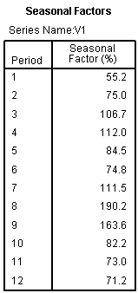

The graph 2 below show the seasonal factor trend in a year .

Graph 2

Seasonal Factor in a Year

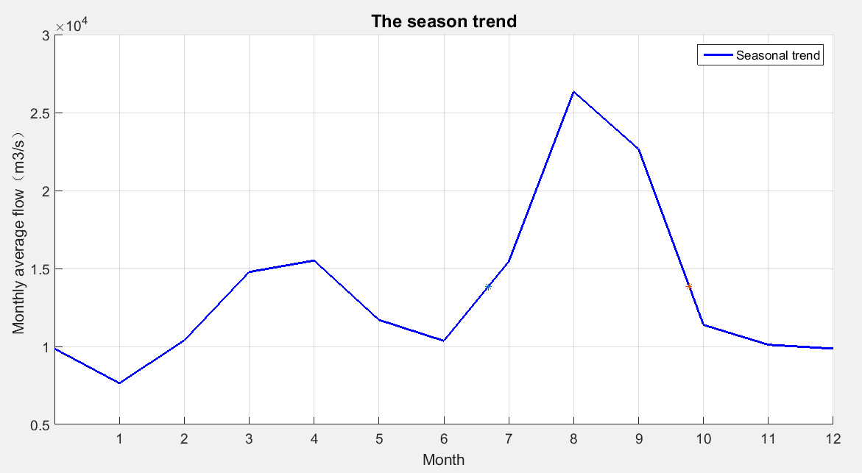

**5.4.2model establishing**

Our goal is to smooth the fluctuation of monthly flow ,to avoid drought and flood .By the formula below ,we can decline the flow fluctuation

+ A (5.4.1.2)

Where $g_{i}$ means the goal we want to achieve ,that is ,the seasonal factor after the transformation .*A* means the mean value of $g_{i}$, *f* means the smooth coefficient .

What’s more , with the expansion of reservoir capacity ,the cost will increase .Therefore, we should take the cost of the building reservoir into account ,and make a balance between cost and water-holding capacity .The cost of the reservoir can be calculated by the formula below

$C=b*V$ (5.4.1.3)

where *C* means the cost of building reservoir ,and *b* means the building cost per 10 million cubic meters ,and we find that and *V* means the water-holding capacity .

The smooth coefficient *f* can be adjusted until the fluctuation of the flow curve is smooth enough and the cost is feasible .We try some different value of the Smooth coefficient *f* ,and get the corresponding cost and water-holding capacity .

Table 2 shows different Smooth coefficient *f* ,corresponding cost and water-holding capacity .

Table 2

different Smoothened coefficient *f* ,corresponding cost and water-holding capacity

|  |  |  |  |
| --- | --- | --- | --- |
| Smoothened coefficient f | | water-holding capacity(10 million ton) | Cost (10 million RMB) |
| 2 | | 162.5093 | 48.7528 |
| 3 | | 216.6791 | 65.00373 |
| 4 | | 243.764 | 73.1292 |
| 5 | 260.0149 | | 78.00448 |
| 6 | 270.8489 | | 81.25467 |

As we can see from the Table 2 ,when f=5 ,the water-holding capacity is enough and the cost is reasonable .

So we determine the Smooth coefficient as 5,in this time ,we can make a balance between cost and water-holding capacity .

Here is the graph about the final result .

Graph 3

The Final Result

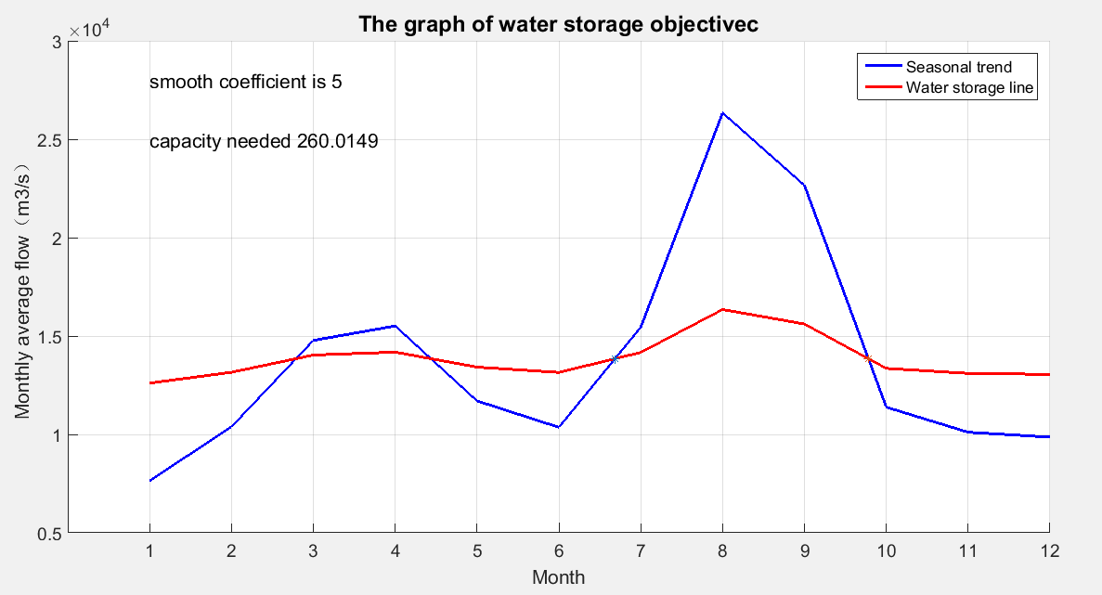

In the early July ,we should start to save water ,on the one hand ,avoid the flood ,on the other hand ,can save water foe the dry season .And in the late July ,we should start to release water ,to meet the need of development and living .